Md. Harun Or Rashid  Room No. 404, Bangabandhu Sheikh Mujibur Rahman Hall,  Jahangirnagar University,  Savar, Dhaka-1342, Bangladesh.  E-mail: ppharun@yahoo.com  Mobile: (+88)01948510890 | 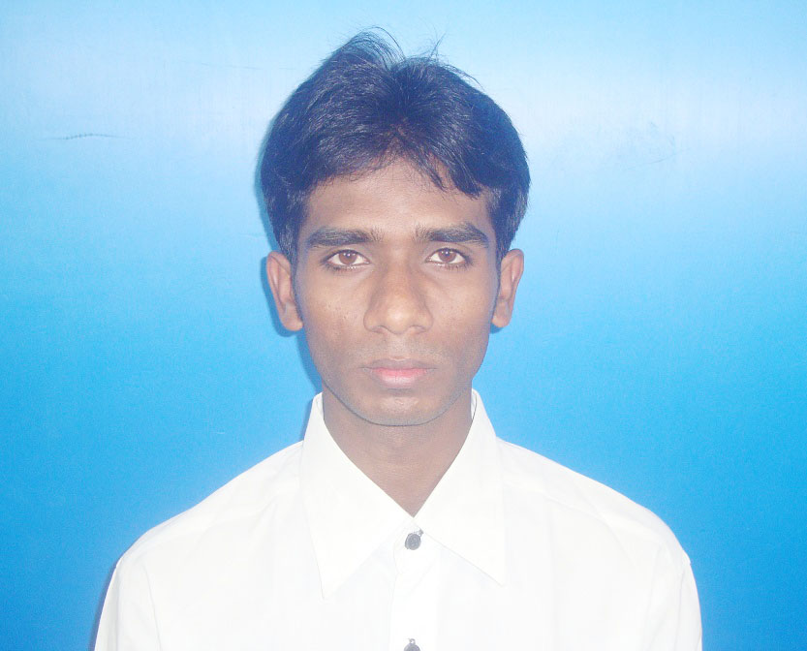

CAREER OBJECTIVE

Seeking an entry level position as a computer engineer to work in a firm with a professional work driven environment where I can utilize and apply my knowledge, skills which would enable me as a fresh graduate to grow while fulfilling organizational goals.

SKILLS AND EXPERIENCE

- Good Skills: OOP using C#, ASP.NET, ASP.NET MVC Framework, Entity Framework, ASP.NET WEB API.

- Specialized Technical Training: OOP using ASP.Net C#, (BDBL Bhaban (5th Floor West), 49 Batch, 12-Kawran Bazar, Dhaka. From BASIS Institute of Technology & Management (BITM).)

- Others IT Skills:

Category | Tools or Activities
Programming and Scripting Languages | C, C++, Java , JavaScript, HTML, CSS, PHP.
JavaScript Framework | jQuery , AngularJS
Frontend UI Framework | Bootstrap 3.0
Editors/IDEs | Microsoft Visual Studio
Databases | Microsoft SQL Server, MySQL
Software development methodology | OOAD, UML
Version Control | Git

EDUCATIONAL PROFILE

Name of Institute | Subject / Group | CGPA | Passing Year
Jahangirnagar University | B.Sc. in Computer Science & Engineering | 3.29 | 2014
H. S. C | Rowmari College | 5.00 | 2009
S. S. C | Rowmari C. G. Jaman High School | 5.00 | 2007
PERSONAL PROJECT WORKS

- My Undergraduate Project:

Project Name | Description
Online Shop Around | App Type: Online Website built using HTML, CSS, OpenCart , PHP.  DBMS: MySQL Server.

- Others Projects:

Project Name | Description
University Management System  Link: https://github.com/HarunChowdhury/University-Management-System | App Type: ASP.NET Web Application built using C# .Net Framework 4.5  IDE: Visual Studio 2012.  DBMS: SQL Server 2012.
RowmariNews24.com  Link: http://rowmarinews24.netau.net/ | App Type: Online Website built using HTML, CSS, Wordpress.  DBMS: MySQL Server.
Agriculture Information  Link: http://krishitotto.site90.net/ | App Type: Website built using HTML, CSS, PHP.  DBMS: MySQL Server.

PERSONAL DETAILS

Candidate’s Full Name | Md. Harun Or Rashid
Father’s Name | Md. Hasanuzzaman
Mother’s Name | Mst. Hasna Begum
Date of Birth | October 25, 1991
Gender | Male
Marital Status | Unmarried
Nationality | Bangladeshi
Religion | Islam
Permanent Address | Vill: Bondaber, Post: Rowmari, Upozilla: Rowmari, Dist: Kurigram
Current Location | Dhaka

REFERENCES

Zohirul Alam Tiemon
CEO Nerd Castle
Cell: +8801711281825
Email: tiemoon@gmail.com.

